Delivery 3

Física orientada a la Modelització i Animació Realista  
Denavit-Hartenberg formalism. Forward kinematic problem

Júlia Gasull i Navarro

Junjie Ji Chen

Aarón Acosta Fernández

# 

# Index

**Index** **2**

**Delivery** **3**

Exercise 1 & 2 3

Exercise 3 4

Exercise 4 & 5 5

Exercise 6 8

Exercise 7 10

Exercise 8 10

# Delivery

For the systems described in the figures:

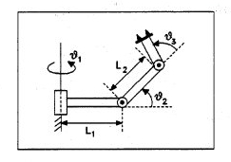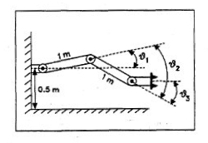

Fig a) Fig b)

## Exercise 1 & 2

Find the reference frames associated with each mobile element, according to the Denavit-Hartenberg rules. Then, find the corresponding D-H tables (use only 3 entry lines, describing just the operations {0 --> 1}, {1 --> 2}, {2 --> 3})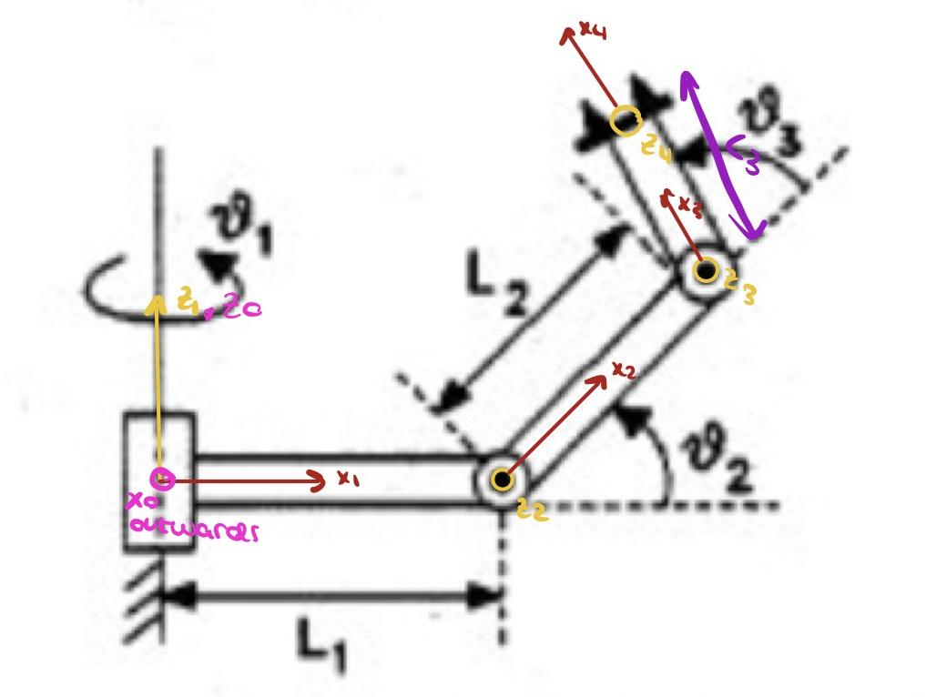

Figure A

|  |  |  |  |  |
| --- | --- | --- | --- | --- |
| **Rx** | **Tx** | **Rz** | **Tz** | {System} → {System} |
| 0 | 0 | θ1 | 0 | {0} → {1} |
| 90º | L1 | θ2 | 0 | {1} → {2} |
| 0 | L2 | θ3 | 0 | {2} → {3} |
| 0 | L3 | 0 | 0 | {3} → {4} |

Figure B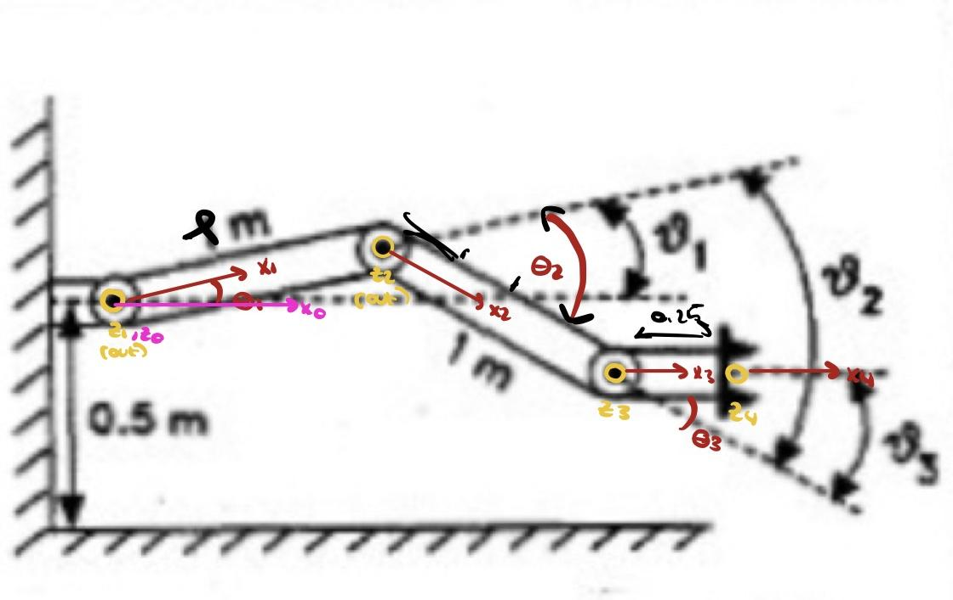

|  |  |  |  |  |
| --- | --- | --- | --- | --- |
| **Rx** | **Tx** | **Rz** | **Tz** | {System} → {System} |
| 0 | 0 | θ1 | 0 | {0} → {1} |
| 0 | L1 | θ2 | 0 | {1} → {2} |
| 0 | L2 | θ3 | 0 | {2} → {3} |
| 0 | L3 | 0 | 0 | {3} → {4} |

## Exercise 3

Create a file 'taula-DH' , with the contents of the D-H values, at a position given by θ1 *= 110º,* θ2 *= 70º,* θ3 *= 80º* for the a) system, and θ1 *= 20º,* θ2 *= -70º,* θ3 *= 80º* for the b) system, that will be read by the pov code that you have in the file **man.pov** (identify in this file the section  */* Taula Denavit-Hartenberg: */* to see the order expected for the 4-values of each row).

Data: *L1 = 1.5, L2 = 1.5, L3 = 1.5*

*Note: In the default {Lab} reference frame used by PovRay, the vertical direction (up) corresponds to the y axis. The {0} reference frame for the systems a) and b) may differ*  in that respect. Therefore the proper location of the {ith} element in each system will require the operations

{Lab} --> {0} --> {1} ... --> {i} Just get sure that the .pov code contains all of them

|  |
| --- |
| **Figure a)** |
|  |

|  |  |
| --- | --- |
| **Figure b without changes from lab to 0** | **Figure b with changes from lab to 0 \*** |
|  | **\*** Rx(-90)*Tz(0.5)*Rx(90) |

## Exercise 4 & 5

Compute the coordinates (Px, Py, Pz) in the {0} reference frame of a point in which a sphere of radius *r = 0.3* will be centered, such that when the system configuration is given by the values of section 3) the far edge of the last element is barely touching the surface of the sphere. Once you have found the (Px, Py, Pz) coordinates, introduce your calculated values for (Px, Py, Pz) in the the **man.pov** file so that the sphere is centered at it (last section of the pov code)

Check that the calculations are o.k. by rendering the scene ( is the sphere being just touched by the 3rd arm of the manipulator?).

|  |
| --- |
| **Figure a)** |
|  |
| **Figure b)** |
|  |

## 

## 

## Exercise 6

Choose a new set of values for the fi's and repeat points 4) and 5)

|  |
| --- |
| **Figure a)** fi1 = 90, fi2 = 30, fi3 = 40 |
|  |
| **Figure b)** fi1 = 90, fi2 = -70, fi3 = 20 |
|  |

## 

## Exercise 7

Modify the file man.pov and create the corresponding man.ini so that you are able to generate an animated sequence in which the articulated system unfolds from the starting position (t = 0) *fi1 = fi2 = fi3 = 0* to the final position of point 6)

|  |  |
| --- | --- |
| **Figure a)** | **Figure b)** |
| Vídeo: [lab3-ex7-a.mp4](https://drive.google.com/file/d/1b9GSqmB0WVTnmREojulh0uyHmc7Ss4OR/view?usp=sharing) | Vídeo: [lab3-ex7-b.mp4](https://drive.google.com/file/d/1AmIZsZCFPVMUEb64WRQieSqYYPCryEMy/view?usp=sharing) |

## Exercise 8

Hand out all calculations, reference frames and D-H tables used in a paper (or document) report. including the gif or mpg sequences generated in section 6).

***In the deliverable.***